**DISK SPACE TROUBLESHOOTING BESIDES DISK CLEANUP**

***Objective*:** *Clear up as much storage space as possible to ensure the store close process can perform without store close failures due to disk space.*

*Below are the File Paths to look at in the store’s register:*

*NOTE: Investigation areas are highlighted in yellow. Noted files will more than likely be based on the size of the file. Some are not listed but will be mentioned in the respected section.*

Listed in order from most common area to least common area to investigate:

1. **c:\environment\log**

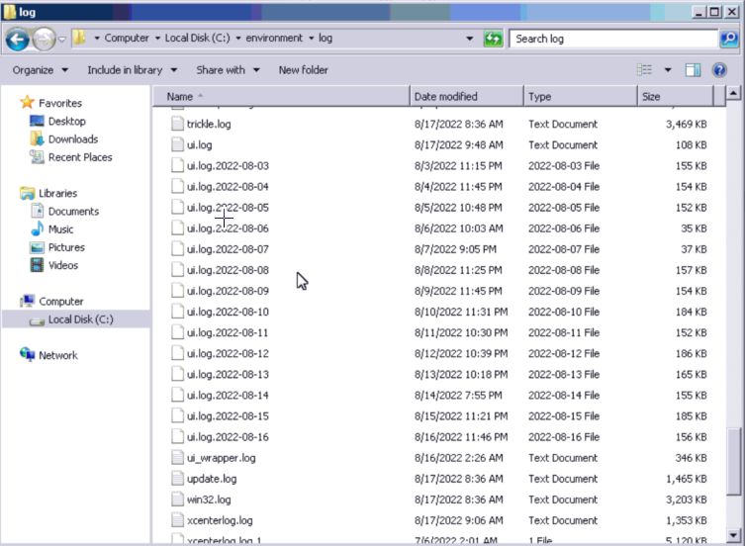



Looking mainly for the biggest UI log size due to errors on that day. This is one of the main folders to investigate for space issues.

1. **c:\xstoredb\backup**Graphical user interface, text, application, email

   Description automatically generated



An old **xstore.bak** file can also be deleted. (Example: xstore.bak001 from months ago)

1. **c:\Users\xstore\AppData\Local\Temp**

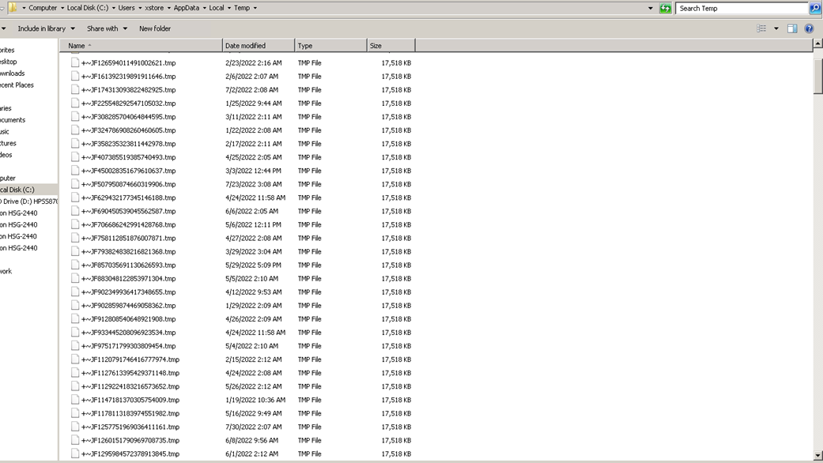



This will be a folder that can be investigated to delete space. These files will have consistent storage sizes and can be deleted. All of these may not be able to be deleted, but that is completely fine. The more you delete, the better.

1. **c:\program files\Microsoft SQL Server\MSSQL11.MSSQLSERVER\MSSQL\Log** (need to be in RDP to access this file path)



Also look for “***SQL MINI DUMP***” files in this folder. Those will be the bulk of files that will take up most of the space due to errors in the database. This will help clear space for sure.

1. **c:\Windows\Logs\CBS**



Most of these will be cabinet files. Look only for large size files.

1. **c:\Windows\Temp** (*need to be in RDP to access this file path*)

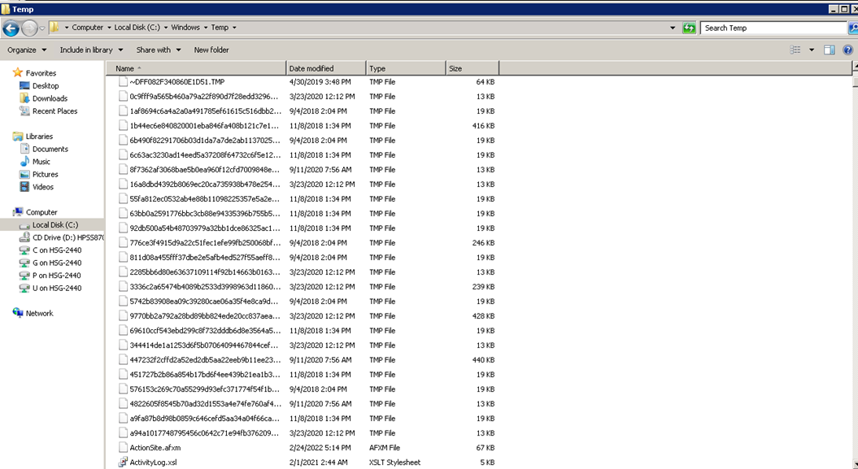



Concentrate on the large size files if needing to investigate this area

**If not above 15 %-disc space at this point continue with the steps below.**

1. **Spacesniffer app**

* To access this, navigate to **G:\Helpdesk\Clint\app**
* To effectively see the entire C drive for the Stores register, copy over the spacesniffer.exe from the **G:\Helpdesk\Clint\app** file path and UNC into the register’s file path (example: \\hibxst0001r01\c$) and paste it in the **xstore** folder.
* Once copied over, then run it and click the **C:\ Drive** to initiate the analysis
* This is used to show what is taking up all the space on the C drive

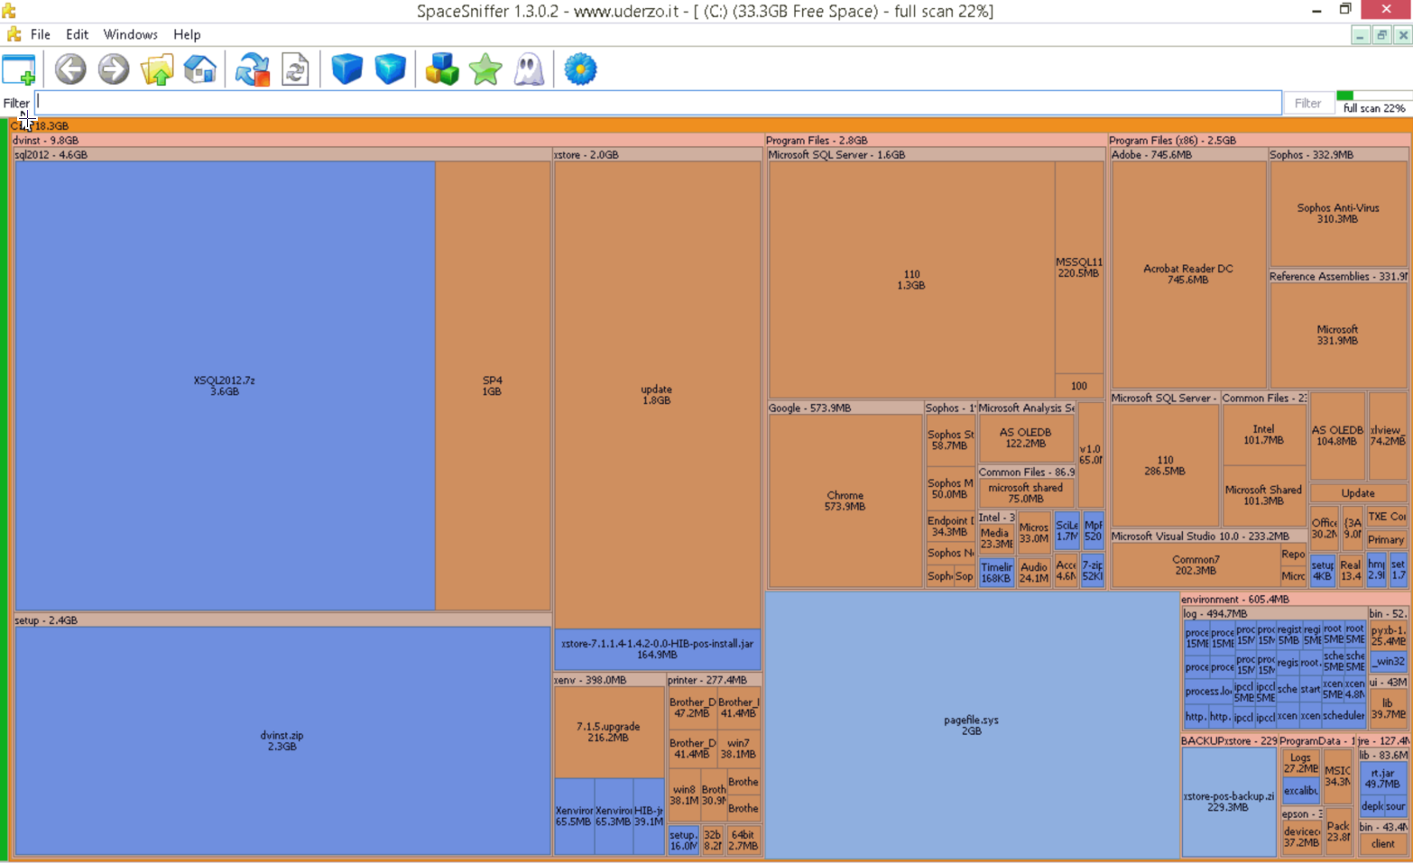

1. ***Big Fix (site version) Disk cleanup ß*** [***KB0010315***](https://hibbett.service-now.com/kb_view.do?sys_kb_id=f149d3a21b37cd9479378622604bcb85&sysparm_rank=1&sysparm_tsqueryId=9db561f247d119148915af5a636d43af)

* This will run a full disk cleanup on the C drive. (***NOTE: This is also a fix for the BSOD errors for Register 1’s***)
* To navigate to this, you will follow this path: **Apps > custom > type in the search bar “disk” and it will pop up the following results.** The one checked below is the one you will choose. (NOTE: anything that says “POS” is meant to be ran for the POS systems.

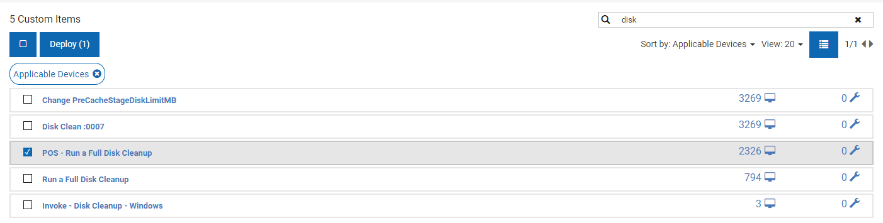

1. ***Big Fix (site version) Bloated log and Temp file clean up ß*** [***KB0010315***](https://hibbett.service-now.com/kb_view.do?sys_kb_id=f149d3a21b37cd9479378622604bcb85&sysparm_rank=1&sysparm_tsqueryId=9db561f247d119148915af5a636d43af)

* This will run a check on the C drive and will attempt to clean up all temp and log files in the C drive. This way is more effective than the disk cleanup.
* To navigate to this, you will follow this path: Apps > custom > type in the search bar “bloated” and it will pop up the following results. The one checked below is the one you will choose. (NOTE: anything that says “POS FIX” is meant to be ran for the POS registers.

1. **Local Disk cleanup**

* Runs a disk cleanup on the Local C:\ drive
* Navigate to control panel and type in “**disk**”. Click “**Free up disk space by deleting unnecessary files**”
* Will clear local data, but for a better cleanup, it will need to be ran via RDC (Remote Desktop Controller)



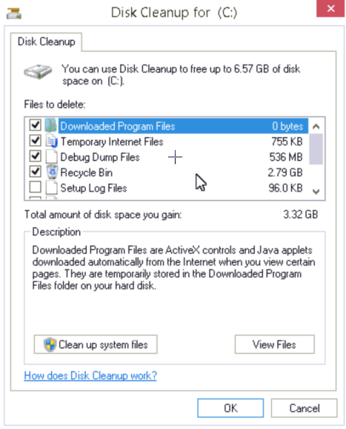

*If you have any other question or concerns, please reach out to your level 2.*